“Skins for Kids”
Come out for a great time and support Tracy
June 10, 9 am shot gun
Support Tracy area youth golf programs and the High school golf teams
Tracy and Mountain House residents play for ½ green fees
Tracy Chamber of Commerce members pay no green fees
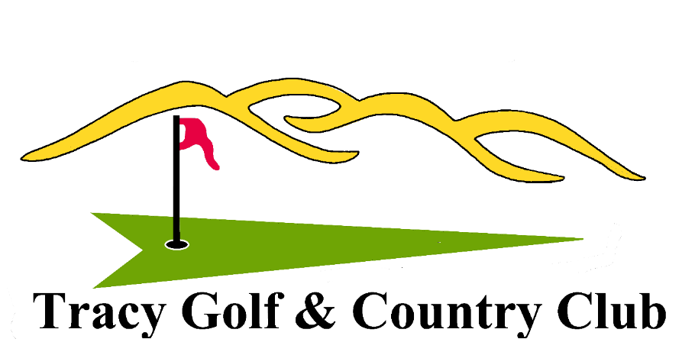
ALL proceeds from green fees, donations and sponsorships will go to
Tracy youth golf programs and equipment

50/50 Skins

www.tracycountryclub.com, 209-835-9463
Tournament or Hole or Youth sponsorships available
Sponsorships

Youth Sponsor
$75 include Green fee, Cart, Skins entry

Hole Sponsors
$150 include Green fees & Cart, Skins entry for two

Tournament Sponsors
$250 include Green fees, Carts and Skins entry for four players

50/50 Skins
½ Skins prize money goes to winners
½ Goes to the programs

ALL proceeds from green fees, donations and sponsorships will go to
Tracy youth golf programs and equipment

